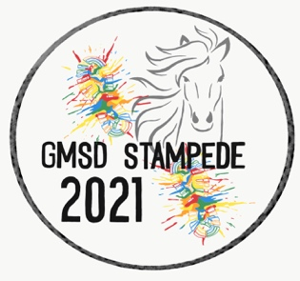

We are going VIRTUAL!!! While we had planned and hoped to have a live 2021 GMSD 5k Stampede and 1 Mile Color Run, it's not in the cards for us again this year. However, we are excited to take our event virtual.

Here is how it works....
1) Please encourage friends and family members to participate.

2)Registration opens March 1, 2021. Early bird registration is $20. After March 18, 2021 the cost of registration will be $25. Students who register early will receive a prize too! There will be no refunds.

3) When you register, please choose what school you are supporting, and what homeroom teacher your child has. Prizes will be awarded for the most participants at each school and to the classrooms with the most participants too! Parents, grandparents, and friends are counted in this total as long as they put a school and a teacher on their registrations!

4) We will continue to take registrations up until race day. However, if you register after April 7th, your t-shirt size will not be guaranteed.

5) All 5k runners will be able to submit your virtual time, along with a photo/screen shot of your tracking device to gmsd5kstampede.raceroster.com

6) T-shirts will be delivered to each participating school on April 14th and 15th. For the people registered that not associated with a school, t-shirt pick-up will be at the Germantown Athletic Club on April 14th and 15th between the hours of 4-7 pm.

7) Maps of 5K and I mile routes will be distributed through school websites, PTO websites, the GEF website, and the Raceroster website. Runners/walkers can choose their own date, time, and route. Times and pictures may be submitted at any time from Friday, April 16th until Sunday, April18th through the Raceroster website. Also, QR Codes will be placed at each school or near each route so participants can “check in”.

8) Please take photos and post to social media. #GMSD5kstampede. Prizes will be awarded to runners with the fastest times!

Please contact Robyn Rudisill with any questions at gef@gmsdk12.org. Thank you so much for your support of GMSD!

